*\*\** ***Jenkins Pipepline Project (declarative)***

Step 1:

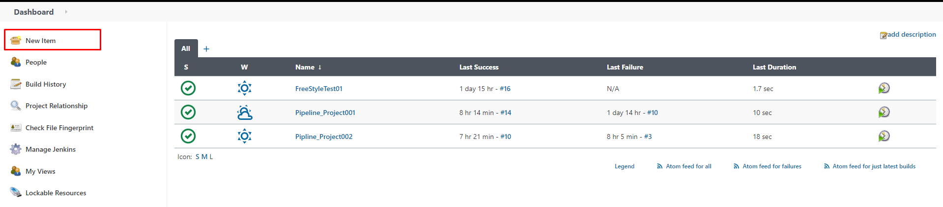

Step 2:

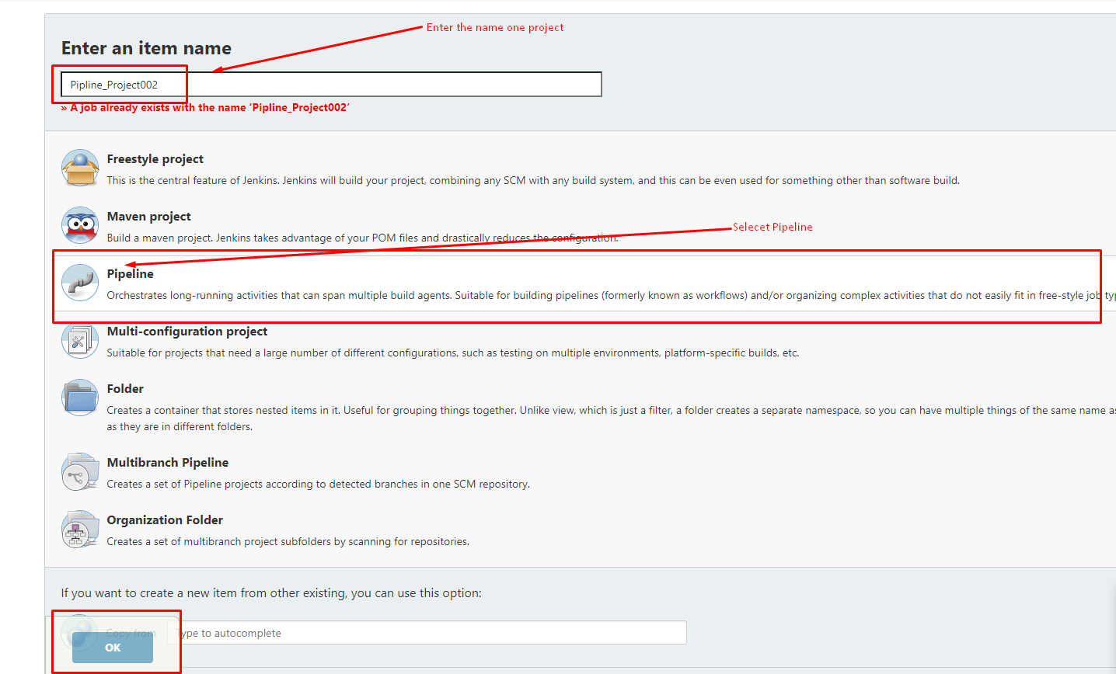

Step 3:

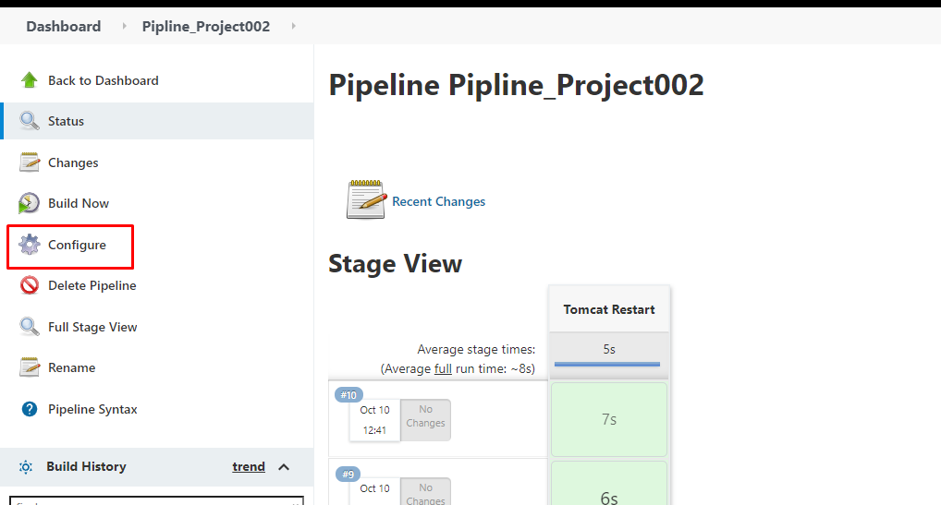

Step 4;

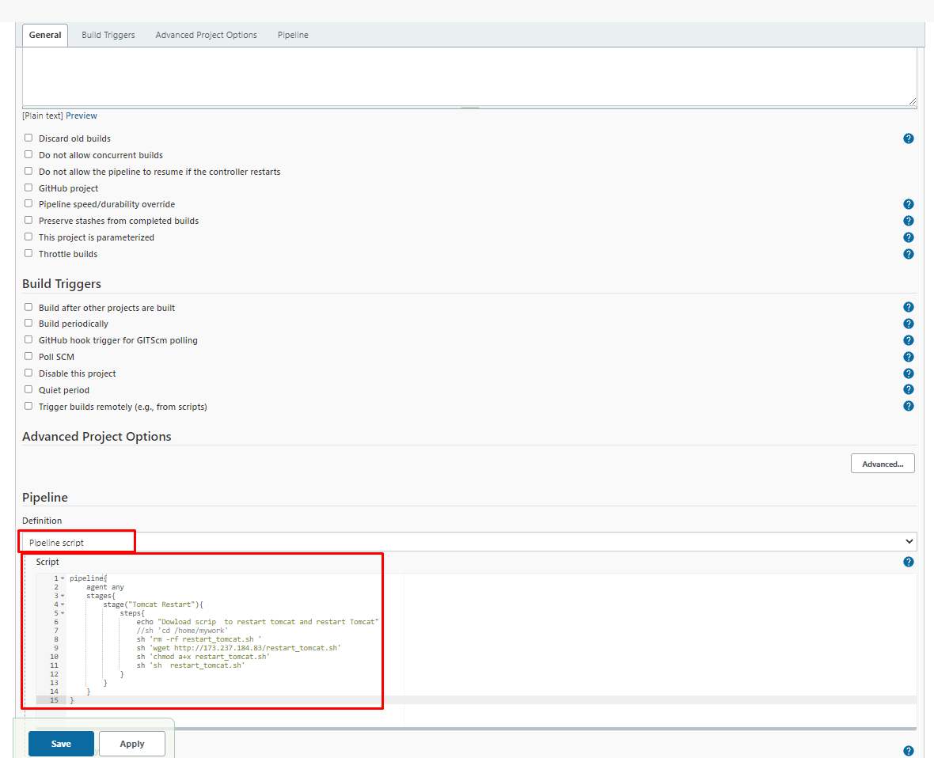

pipeline {

agent any

stages {

stage("Stage001") {

steps{

echo "Hello All , This is my first step of Stage001"

//echo "Hello All , This is my second step of Stage001"

sh '''chmod a+x /home/mywork/name.txt

echo "Sheikh Abreeq Islam" >> /home/mywork/name.txt'''

sh 'sh /home/mywork/test.sh'

}

}

stage("Stage002"){

steps{

echo "Hello All , This is my first step of Stage002"

}

}

stage("Stage003"){

steps{

echo "Hello All , This is my first step of Stage003"

}

}

}

}

Step 5:

